I have been using Terraform for a while to launch my infrastructure in AWS, Google Cloud, and Azure and I am loving it since I do not need to learn different sets of languages or syntax for different Cloud Providers.
My only challenge when it comes to Terraform is that the installation instruction in the terraform site is not as detailed as I want it to be.
So here’s a tutorial on how to install Terraform in Windows 11 and make it work in Command Prompt, Powershell, and Git Bash with instructions and screenshots you can follow
Terraform installation
- Download Terraform binary for Windows
- Extract terraform.exe
- Add Terraform folder in Path Environment Variable
- Testing terraform Command

1. Download Terraform binary for Windows

Go to https://developer.hashicorp.com/terraform/install then go down for your desired Operating System select processor type 386 or ARM look for the Windows section. Click on Download.

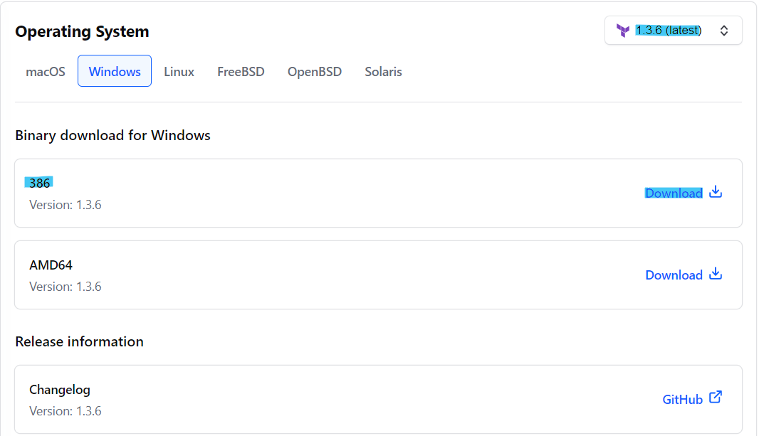

So the filename of zip file is terraform_1.1.36_windows_amd64.zip.

Note : If you are following these instructions at a later time, then the version might be updated, thus the filename should also be different. But the steps should still be the same.

2. Extract the terraform.exe
Need to extract the terraform.exe inside the zip file, then extract it to our target folder.
In our case target folder is in C:\Programs\Terraform\. Yours can be a different folder or directory.

Right-click on the terraform zip file and click on Extract All…
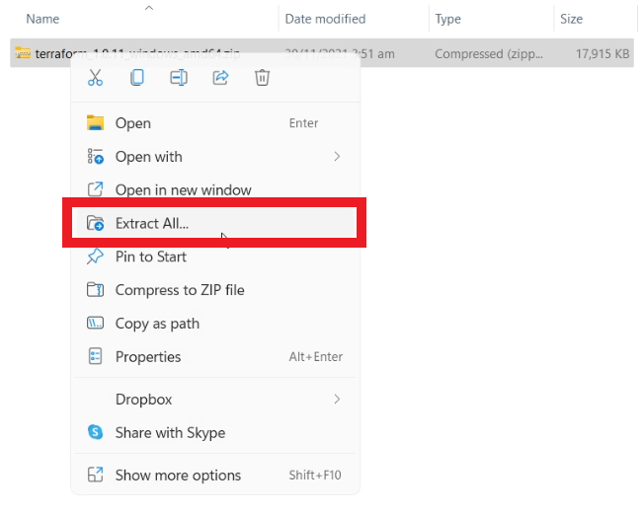
Click on Browse and go to your target folder, then click on Extract for the extraction process to start.
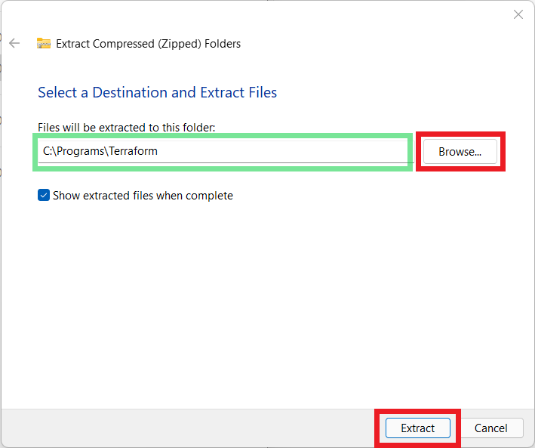
Once the extraction process is done, you should see terraform.exe in your target folder.
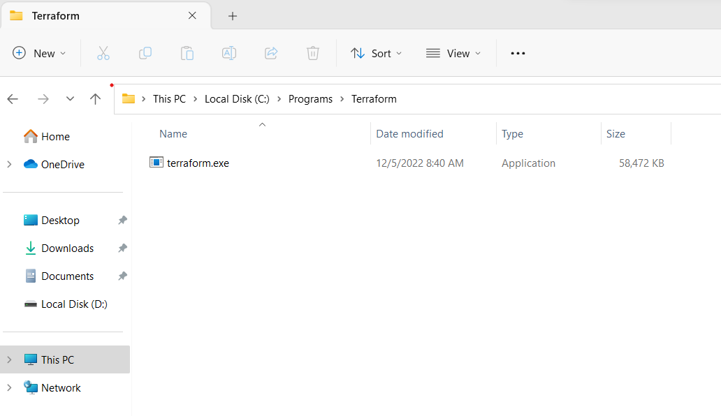

3. Add Terraform folder in Path Environment Variable
The Path Environment Variable is a list of where the PowerShell, Command Prompt, or Git Bash will look to find a command.

To add the Terraform folder in the Path Environment Variable, click on the Start Menu and search for environment.
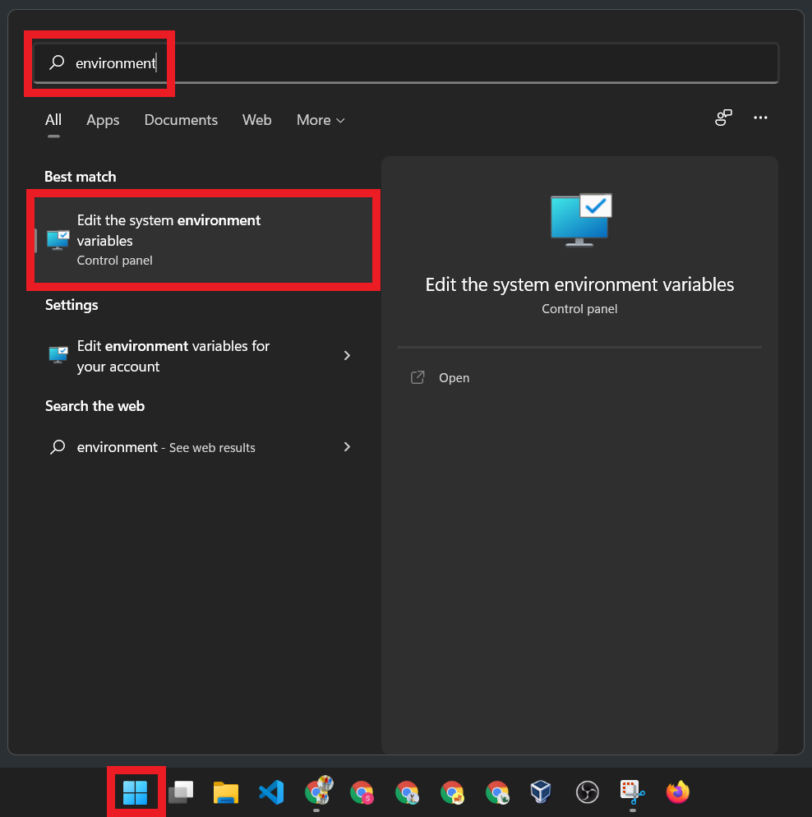
Then click on Environment Variables…
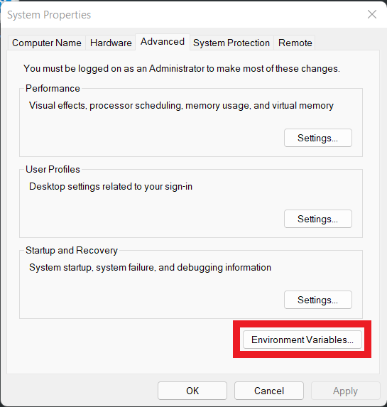
This will open the Environment Variables window.
Under the User variables for your Username, click on Path. Then click Edit.
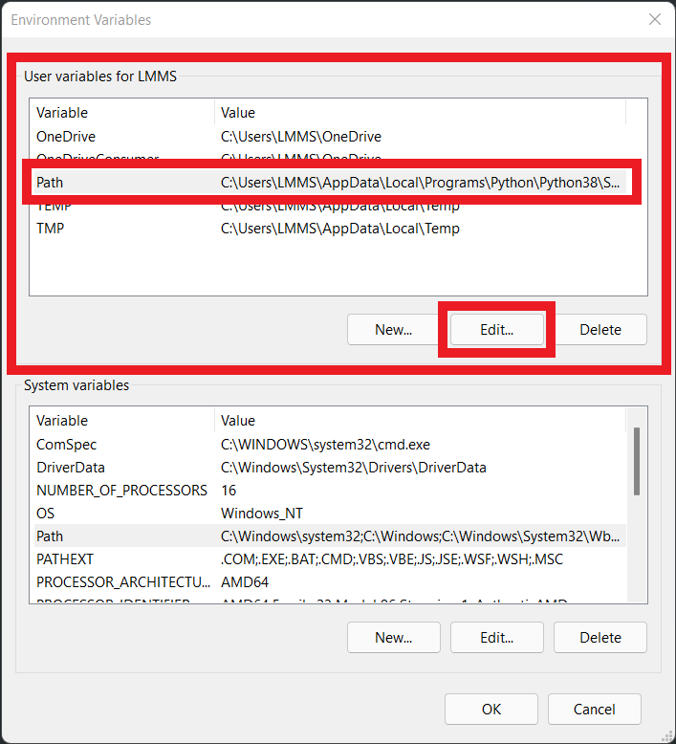
In the Edit Environment Variable window, click on New.
Then enter the folder location where you placed your terraform.exe. You can use Browse… if you want to.
Then click OK.
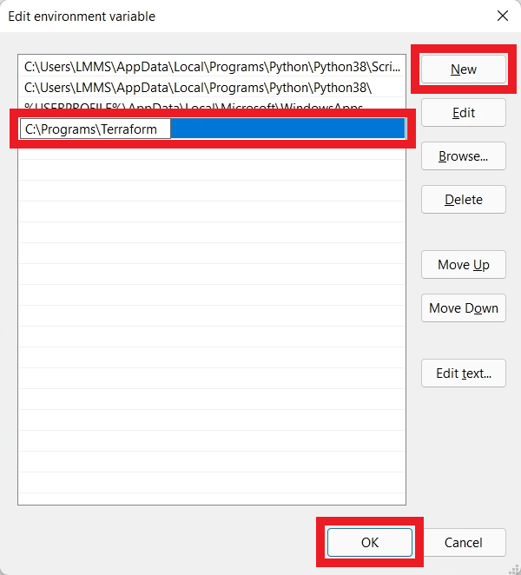
When you go back to the Environment Variables window, just click OK.
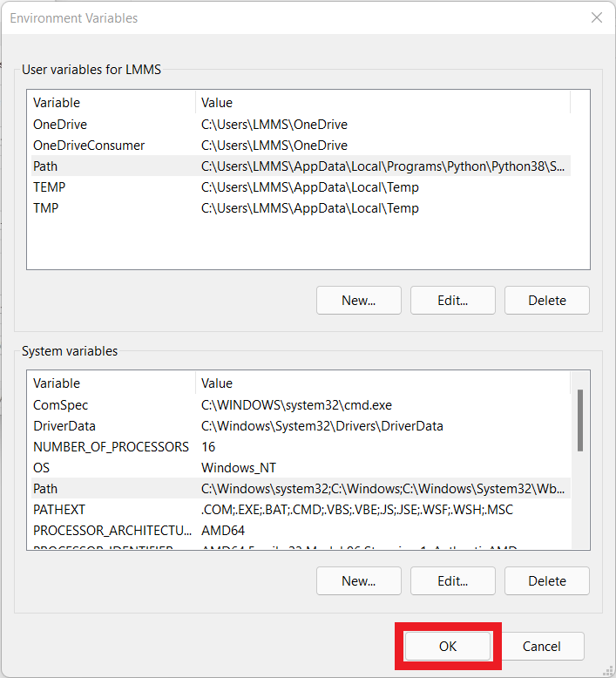
Next would be to test if terraform commands are now working.

4. Testing terraform Command
Close all instances of Powershell, command prompt, or Git Bash.
Then launch them again, and run the terraform --version command, this time it will work.
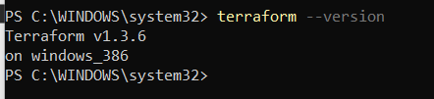
PowerShell

